MATHEMATICS FOR COMPUTING



PRACTICAL FILE
RAMANUJAN COLLEGE

Submitted By:-
NAME: GAOHAR IMRAN
COLLEGE ROLL NO: 25570022
COURSE: B.Sc. (Hons) Computer Science

Submitted To:-
Dr. Aakash
Assistant Professor
Department of Computer Science,
Ramanujan College, University of Delhi, CR Park, Main Road,
Block – H, Kalkaji, New Delhi
Pincode - 110019

Acknowledgement

This practical file for Mathematics for Computing has
been completed as part of the requirements for the
B.Sc. (Hons.) Computer Science course at Ramanujan
College, University of Delhi.

I acknowledge Dr. Aakash, Assistant Professor
(Operational Research), for overseeing the course and
providing the necessary guidance and structure for the
practical component.

I also appreciate the academic environment and
resources of the Department of Computer Science,
which facilitated the completion of this work.

List of Practicals:-

1. Create and transform vectors and matrices (the transpose vector
(matrix) conjugate a. transpose of a vector (matrix))
2. Generate the matrix into echelon form and find its rank.
3. Find cofactors, determinant, adjoint and inverse of a matrix.
4. Solve a system of Homogeneous and non-homogeneous equations
using Gaussian elimination method.
5. Solve a system of Homogeneous equations using the Gauss Jordan
method.
6. Generate basis of column space, null space, row space and left null
space of a matrix space.
7. Check the linear dependence of vectors. Generate a linear
combination of given vectors of Rn/ matrices of the same size and find the transition matrix of
given matrix space.
8. Find the orthonormal basis of a given vector space using the
Gram-Schmidt orthogonalization process.
9. Check the diagonalizable property of matrices and find the
corresponding eigenvalue and verify the Cayley- Hamilton theorem.
10. Application of Linear algebra: Coding and decoding of messages
using nonsingular matrices. eg code “Linear Algebra is fun” and then decode it.
11.Compute Gradient of a scalar field.
12. Compute Divergence of a vector field.
13.Compute Curl of a vector field.

# Practical 1
Create and transform vectors and matrices (the transpose vector (matrix) conjugate
- transpose of a vector (matrix)

Code:

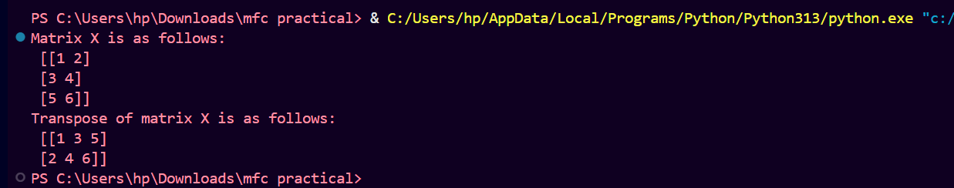
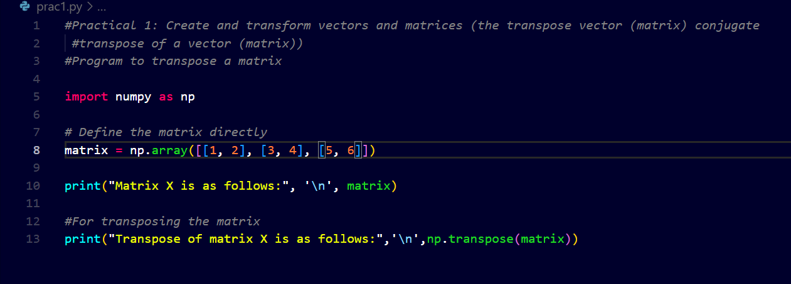
Output:-

# Practical 2
Generate the matrix into echelon form and find its rank.

Code:-

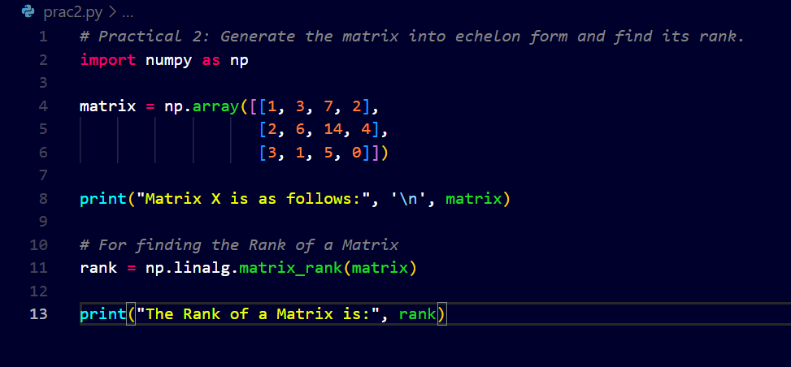
Output:-

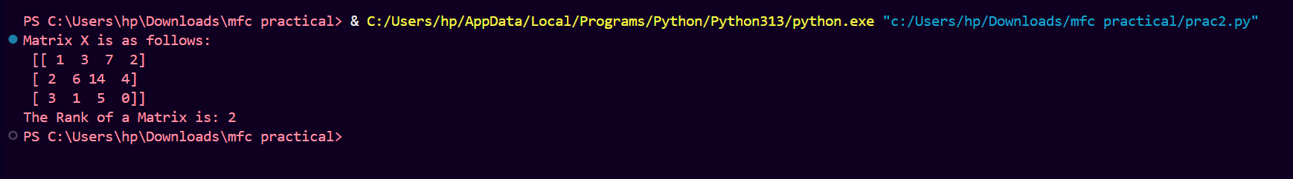

# Practical 3
Find cofactors, determinant, adjoint and inverse of a matrix.

Code:-

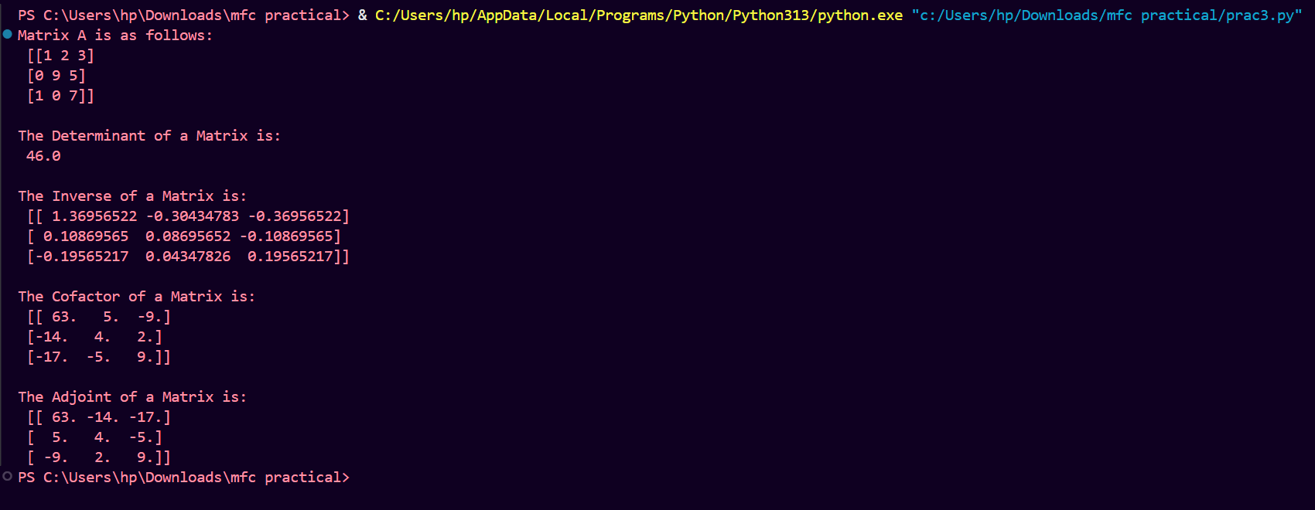
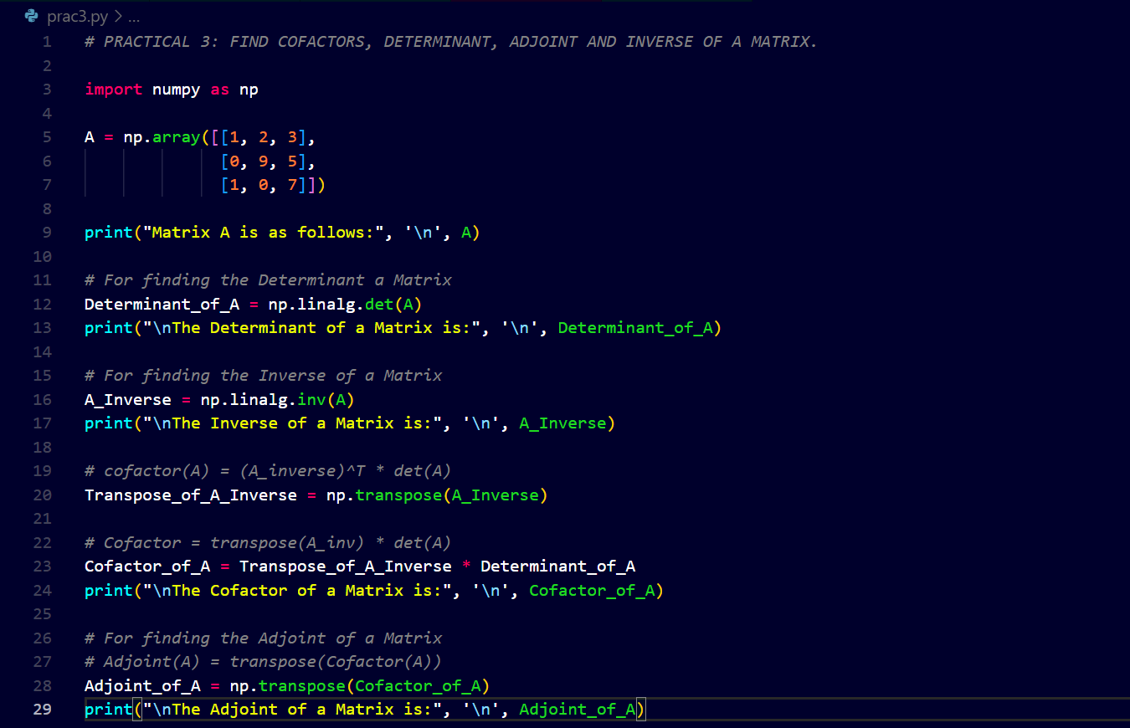
Output:-
# Practical 4
Solve a system of Homogeneous and non-homogeneous equations using
- Gauss elimination method.

Code:-

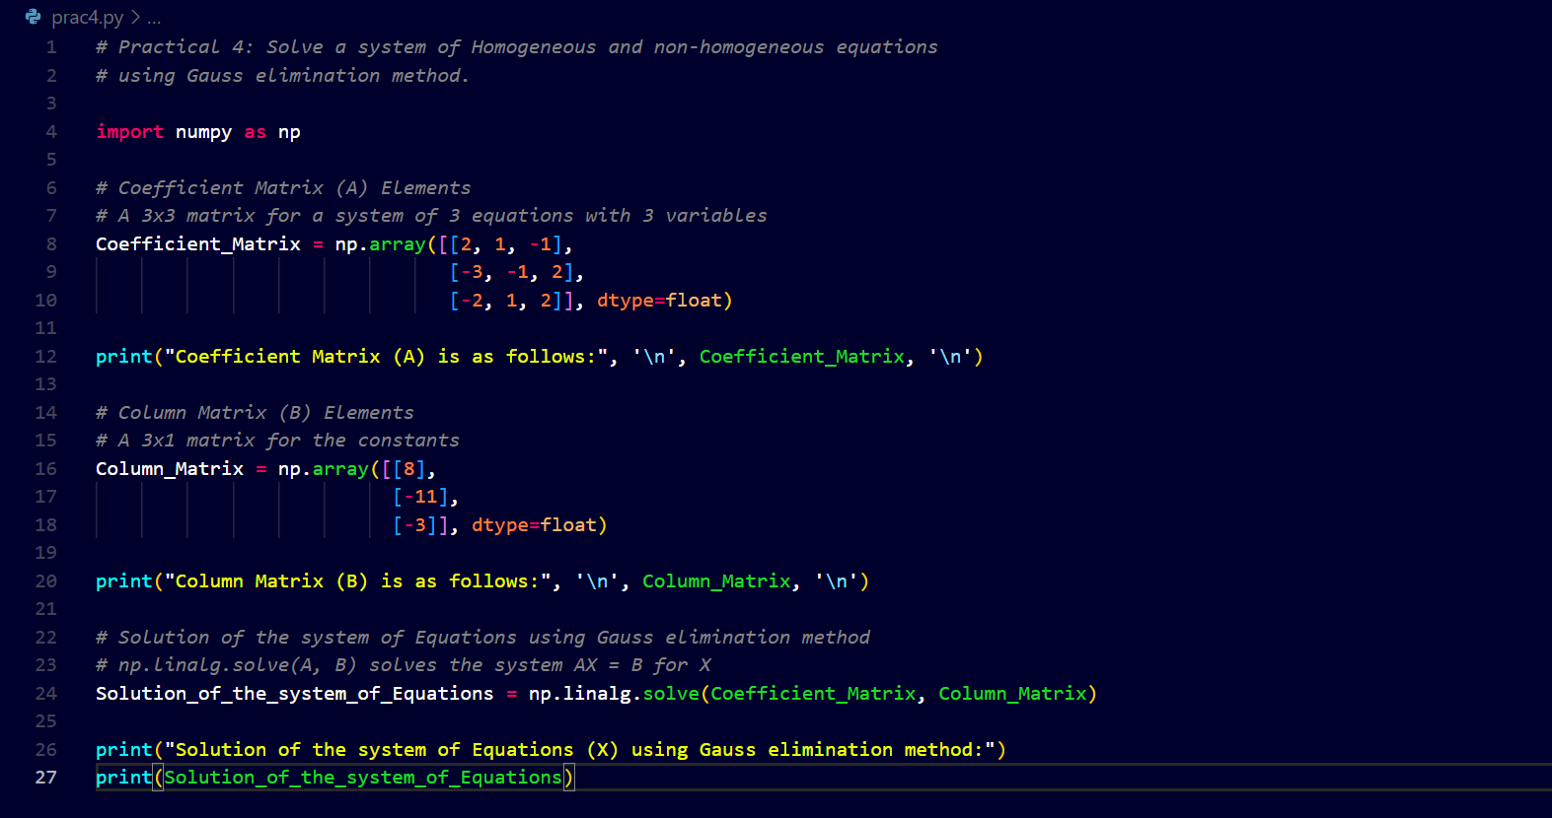
Output:-

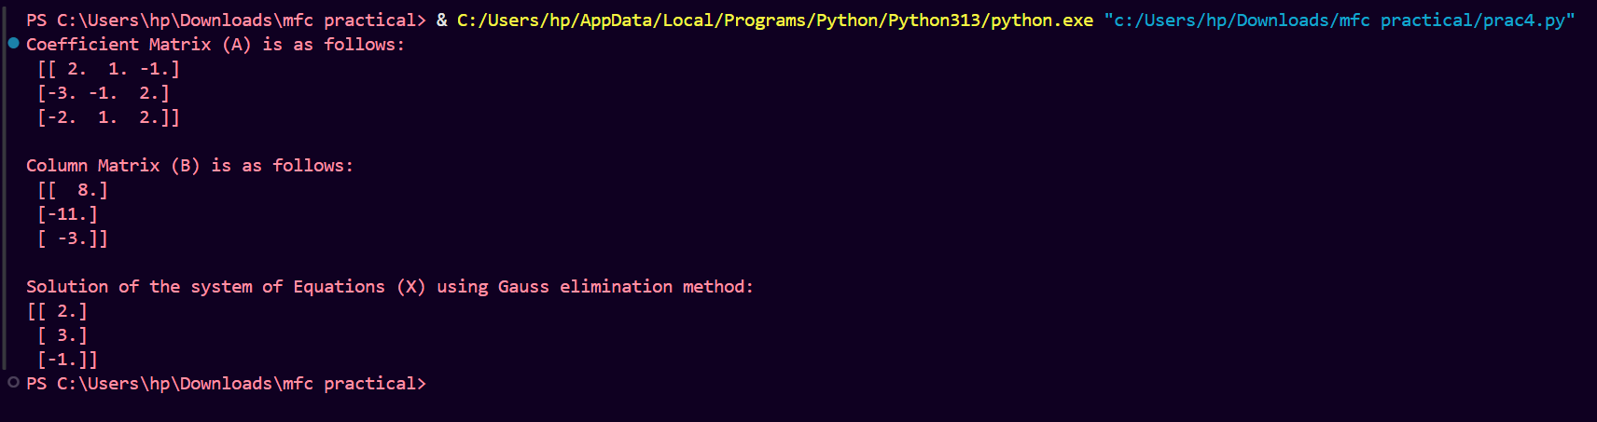

# Practical 5
Solve a system of Homogeneous equations using the Gauss Jordan method.

Code:

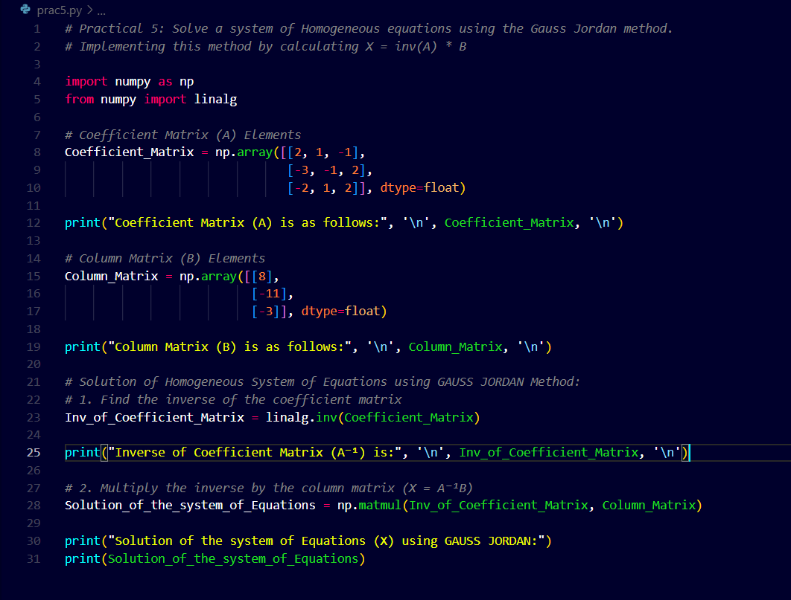
Output:-
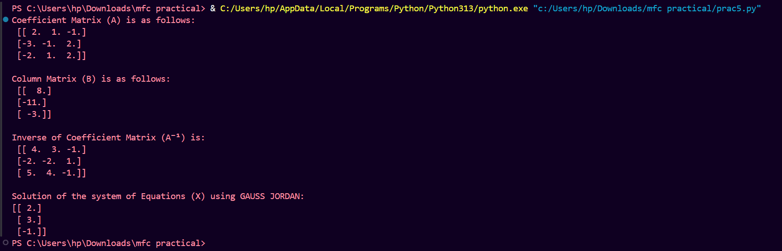
# Practical 6
Generate basis of column space, null space, row space and left null space of a matrix space.

Code:-
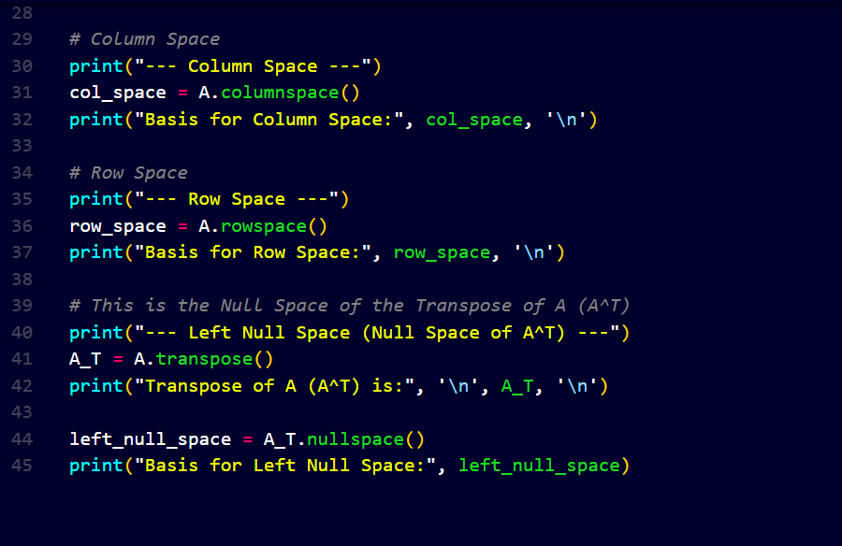
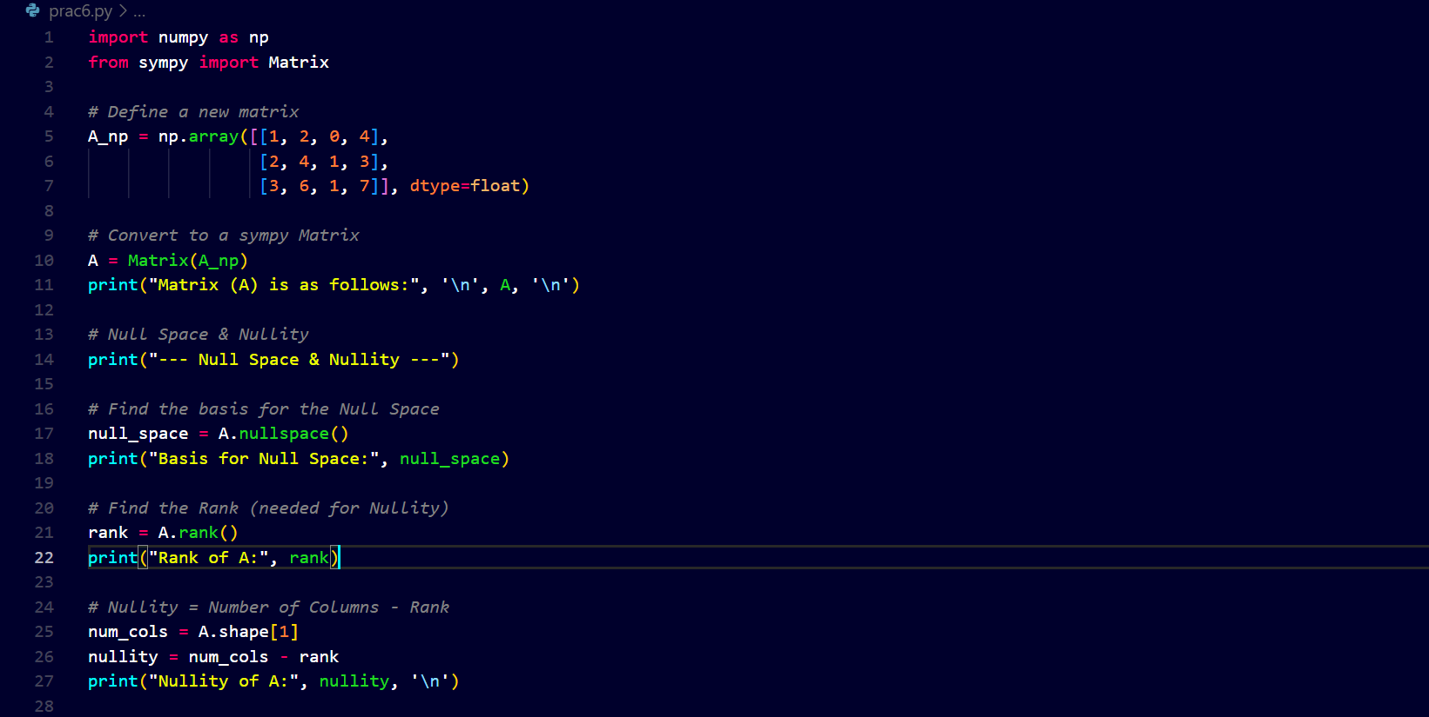
Output:-
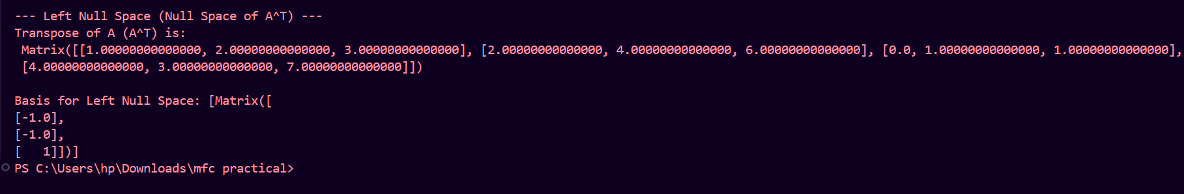
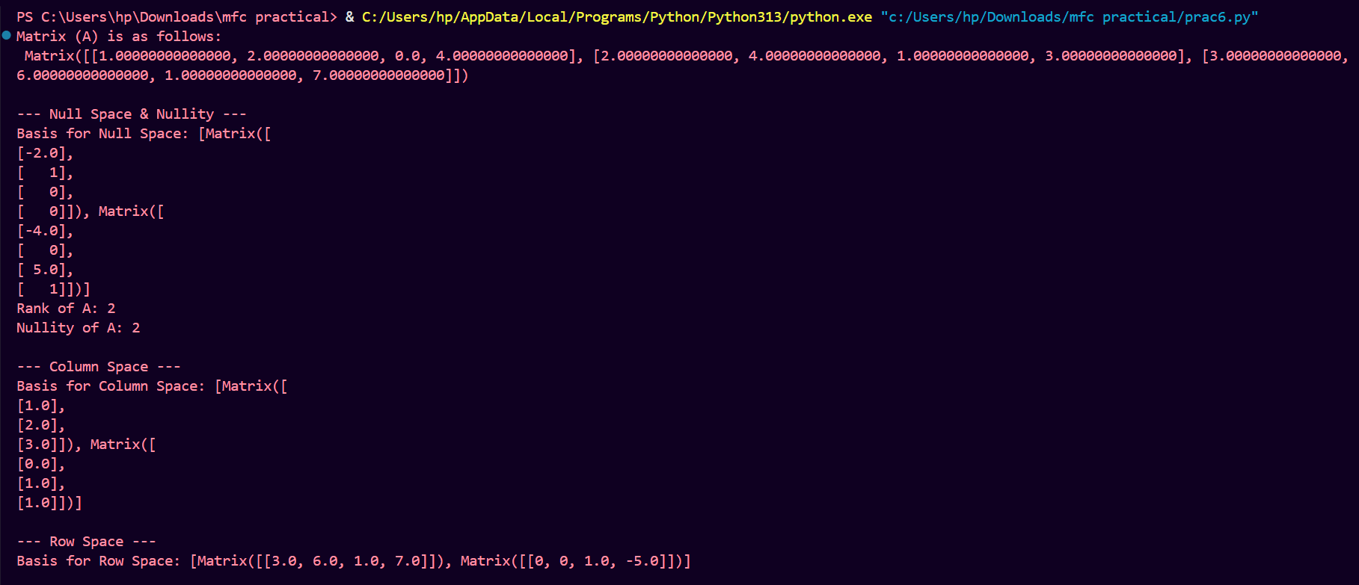

# Practical 7
Check the linear dependence of vectors. Generate a linear combination of given vectors of Rn/ matrices of the same size and find the transition matrix of given matrix space.
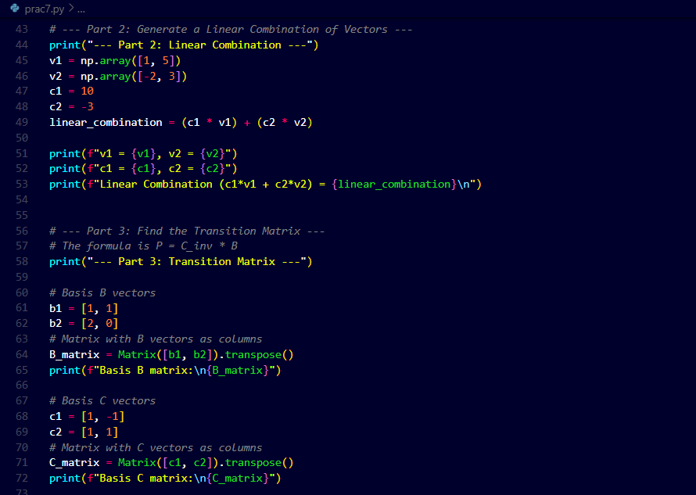
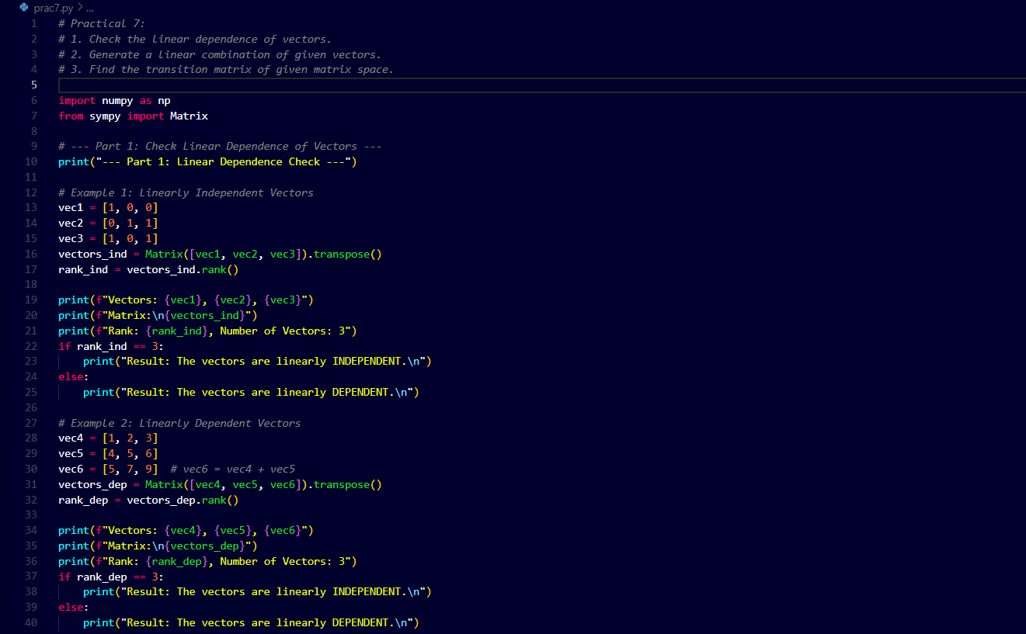
Code:

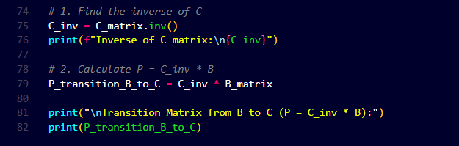
Output:-
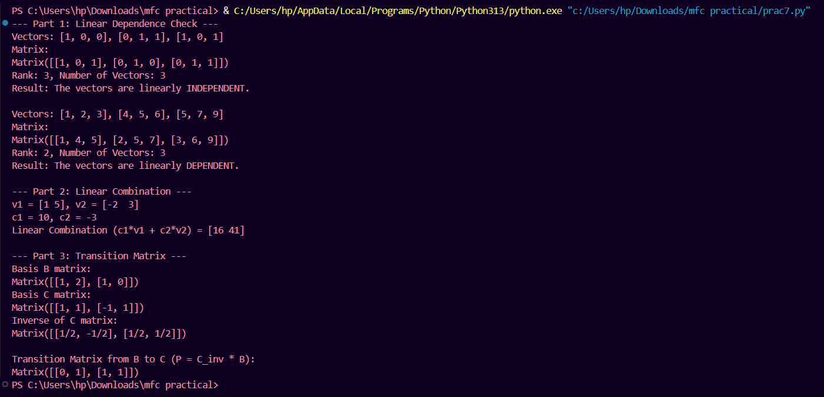

# Practical 8
Find the orthonormal basis of a given vector space using the
Gram-Schmidt orthogonalization process.
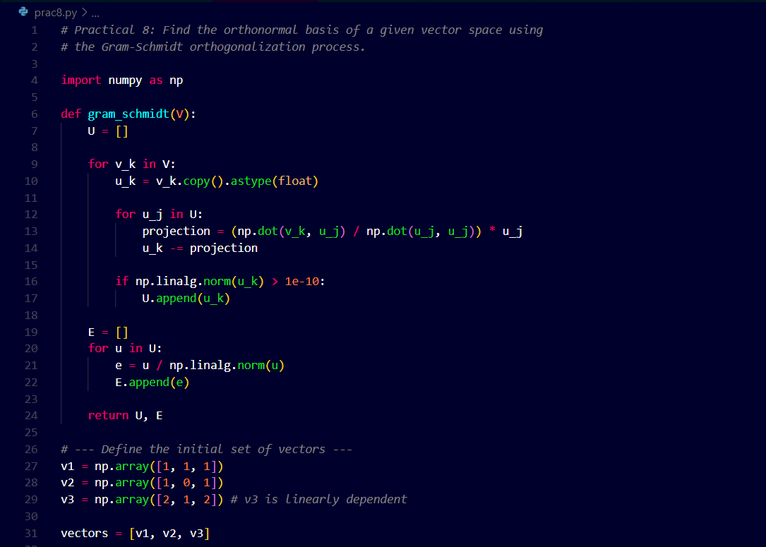
Code:-
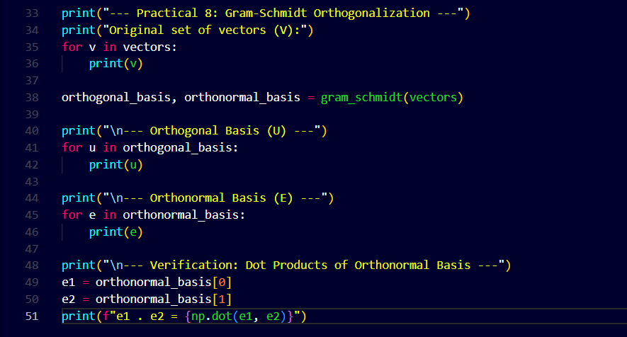

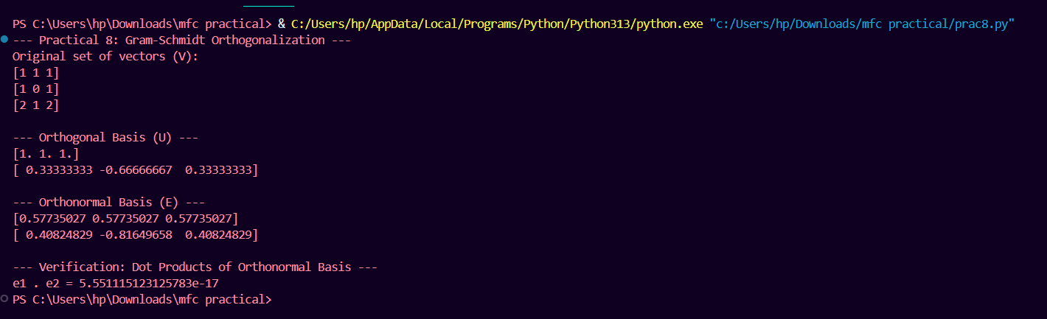
Output:-

# Practical 9
Check the diagonalizable property of matrices and find the corresponding eigenvalue and verify the Cayley- Hamilton theorem
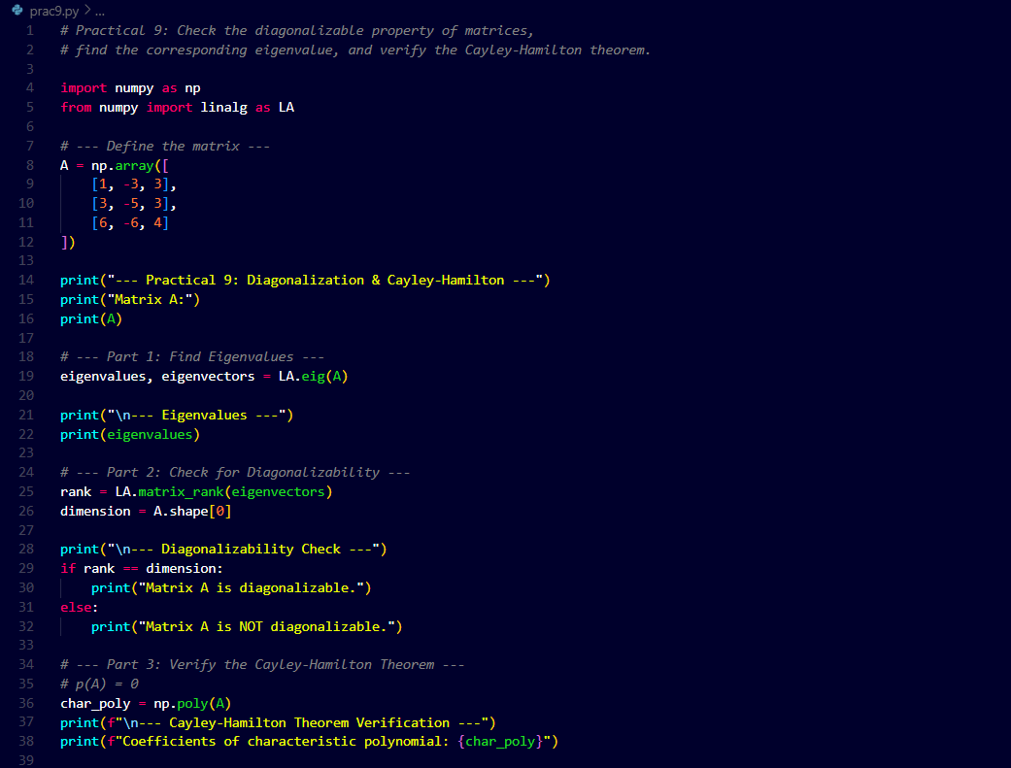
Code:-

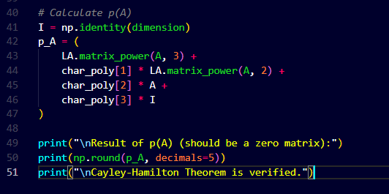
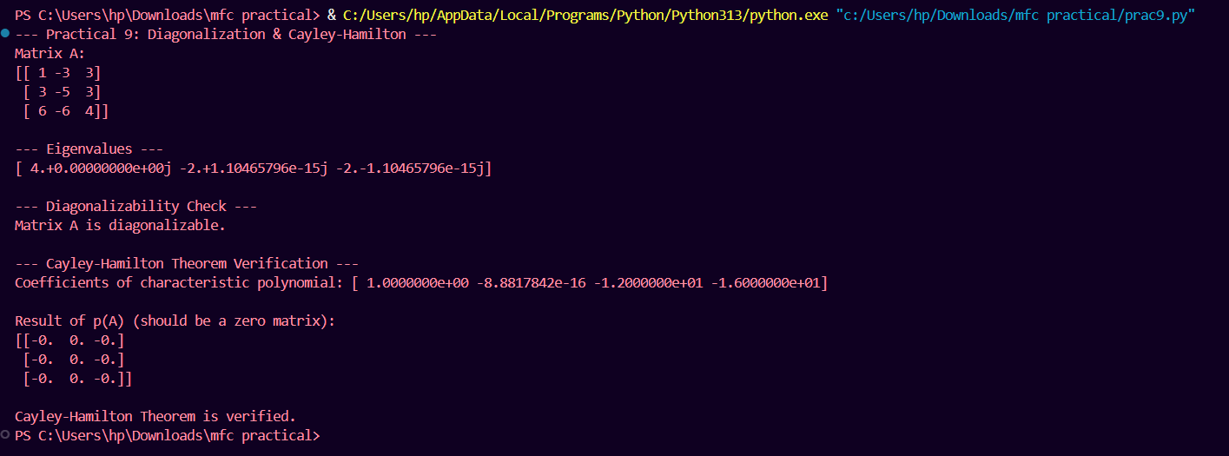
Output:-

# Practical 10
Application of Linear algebra: Coding and decoding of messages using nonsingular matrices. eg code “Linear Algebra is fun” and then decode it.

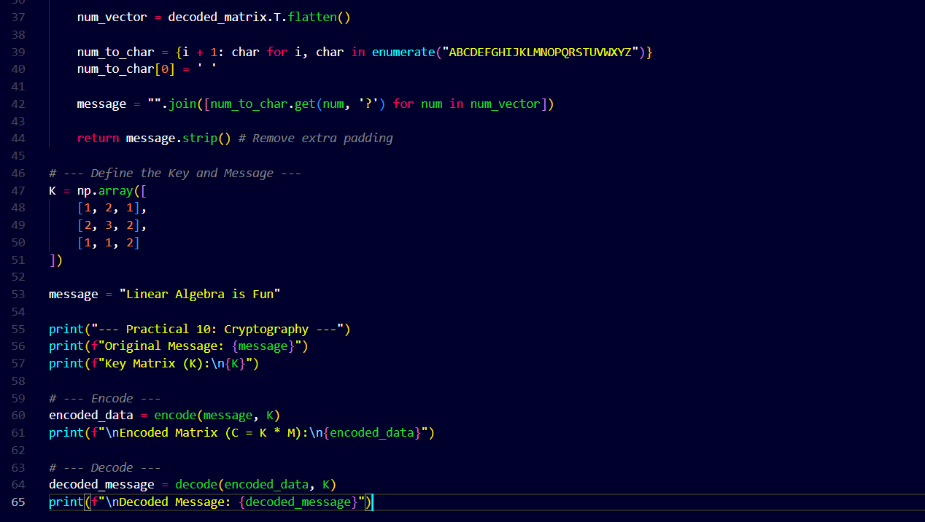
Code:-
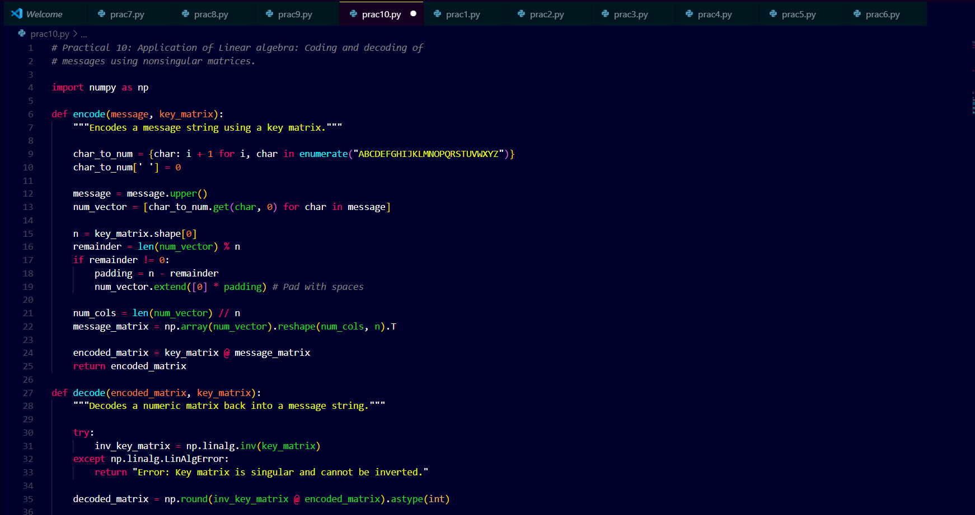
Output:-
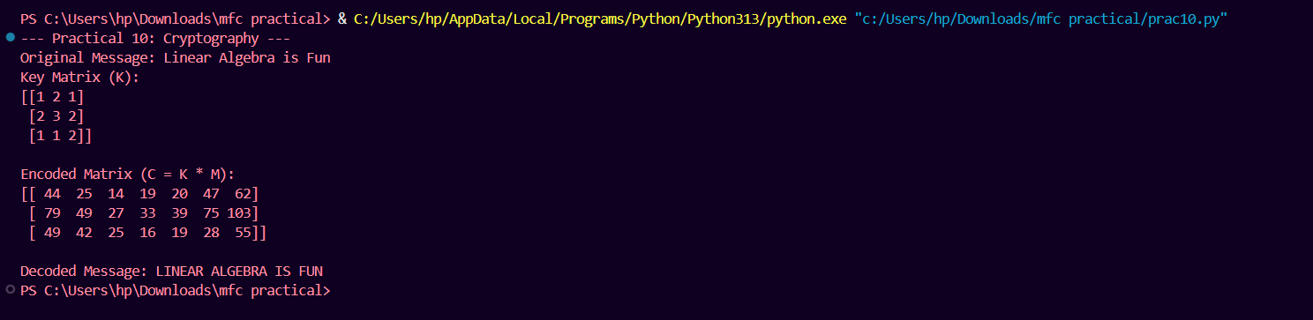

# Practical 11
Compute Gradient of a scalar field.

Code:-
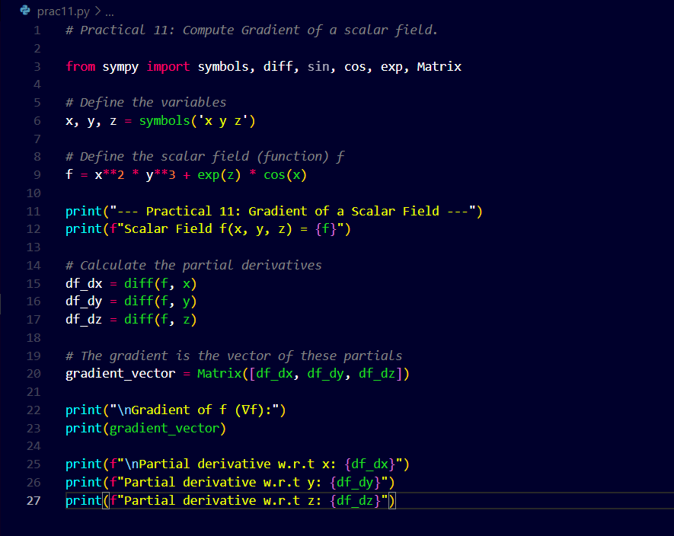
Output:-
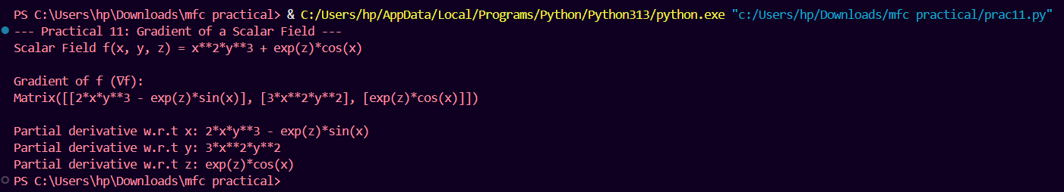

# Practical 12
Compute Divergence of a vector field.

Code:-
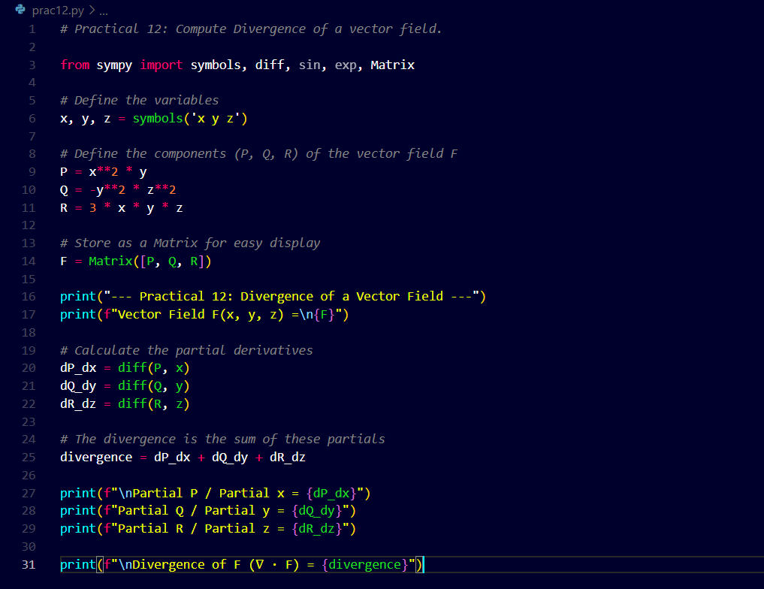
Output:-
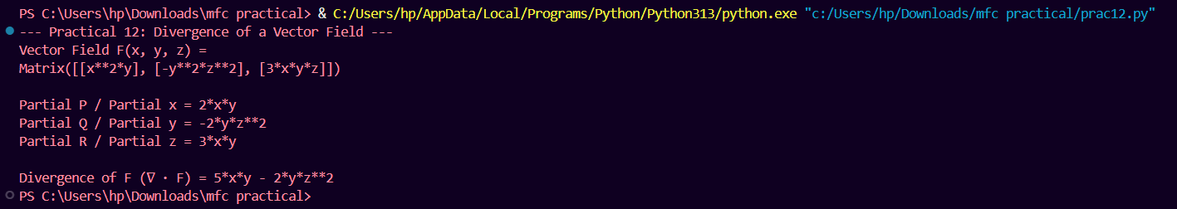

# Practical 13
Compute Curl of a vector field.

Code:-
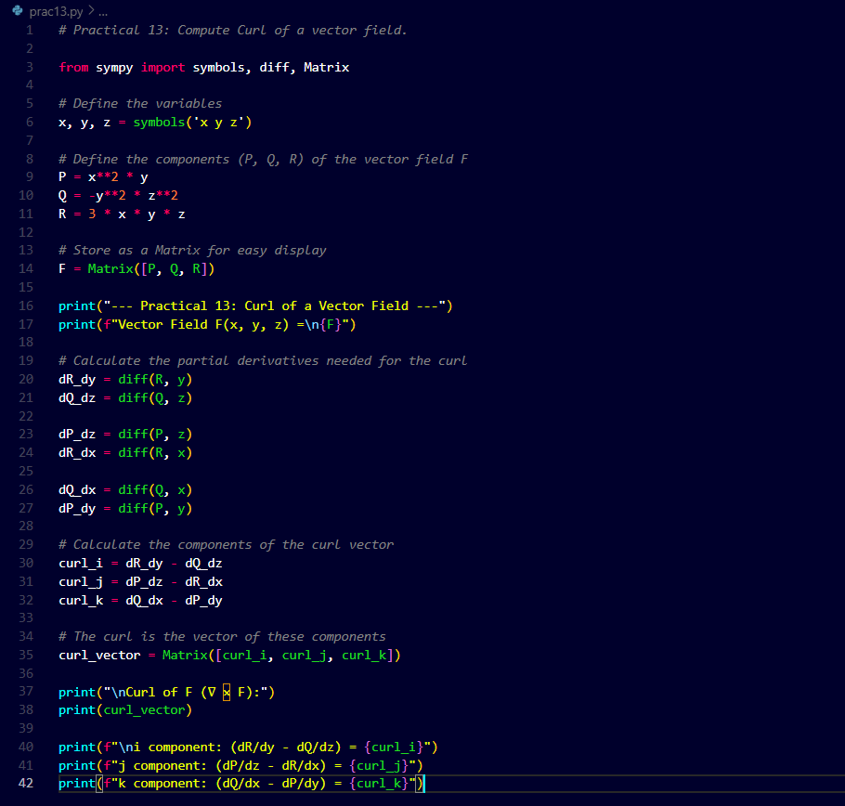
Output:-
